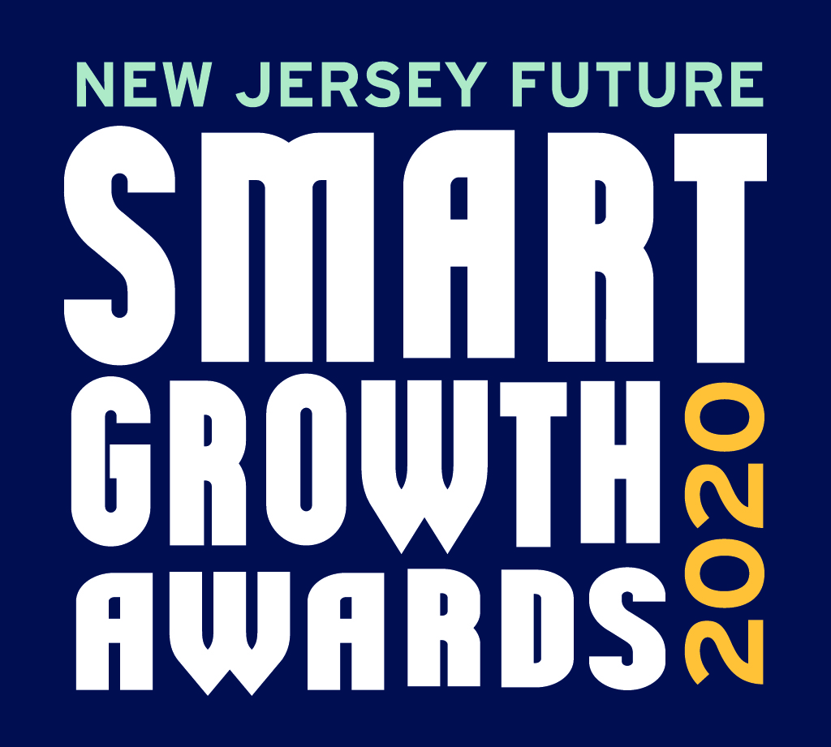
2020 Smart Growth Awards
Project Narrative Questions

All submissions must be uploaded by Friday, January 17, 2020.

Submit via https://njfuture.org/sgasubmissions.

Project Name:

Please tell us in detail about the project you are nominating by answering the questions below. Please answer all questions, using their respective headings, and upload the narrative as a Word document when complete. Please include the project name in the filename.

Context
How does the project fit into its community or neighborhood, the municipality and/or region – geographically, stylistically, culturally, functionally, and any other relevant ways? Please also highlight any ways in which the project aligns with or improves on existing community and/or regional plans.

Implementation and Impact
For adopted plans: How will the plan will be implemented, and over what time period?

For projects: When did construction begin? When was it finished, or, if it is still under construction, what percentage has been completed and what is the timeline to full completion?

For all entries: What impact has the project made or will it make on the surrounding community and/or region? Please include such factors as physical space, cultural connections, property values, increase in activity, better walkability and biking, access to transit and amenities, additions to open or recreational space, and any other impacts. You may provide news articles or other independent documentation of your project to demonstrate its impact beyond its own footprint.

Green Stormwater Infrastructure
Does the project make use of green infrastructure techniques to help manage stormwater? If so, please provide relevant details, such as the quantity of stormwater it is designed to handle and some of the community benefits (beyond stormwater management) they provide.

Climate Resiliency
Does the project represent an opportunity for increased resiliency to future climate change and severe weather? If so, please provide details of measures taken, features incorporated, etc., and include some way to evaluate success against projected reduction in vulnerability.

Expanded Housing Choices
In what ways does your project expand the available housing choices? What elements of any housing shortage will your project address? If your project is in a higher-income community, how many affordable units are included? Are there new housing types (apartments, townhouses, etc.) to meet the needs of older residents and/or young adults? Are you bringing market-rate housing to an emerging neighborhood?

Mix of Uses and Accessibility
In what ways does your project bring different types of uses – housing, commercial, retail, transportation, public spaces – closer together? Is there an emphasis on mobility via means other than cars, through things like provisions for walking and cycling, and innovative approaches to parking?

Partnerships and Collaborations
What individuals and entities were essential to shaping and/or implementing the project? What partnerships were you able to form, including across municipalities or other government entities? What made the partnerships effective or not?

Stakeholder Outreach
Which stakeholder groups were or will be affected by this project, and how have you engaged them in guiding it? How did you ensure that all groups and voices, including under-resourced groups, groups whose first language is other than English, etc., had meaningful input? How did you keep them informed? How did you measure effectiveness? How did the plan or project change as a result of outreach?

Challenges
What challenges did you anticipate at the outset? What unexpected problems or setbacks arose as the project progressed? How did you plan for, address and overcome these challenges? What advice from this can you offer that could help other jurisdictions avoid similar pitfalls?

Lessons Learned
Overall, what did you learn from the success of this project that you can share with others who might want to attempt something similar? What examples or innovations can the project provide to improve planning, design, public involvement and smart growth in New Jersey?

