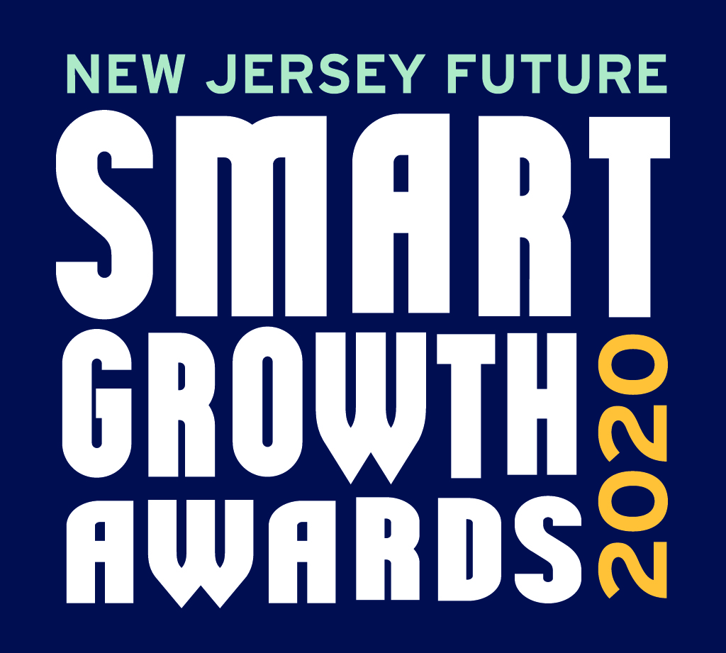
2020 Smart Growth Awards
Guidelines and Nomination Instructions

Submit via https://njfuture.org/sgasubmissions.

New Jersey Future’s Smart Growth Awards honor projects, plans, and initiatives in New Jersey that demonstrate smart growth principles in action. The awards shine a spotlight on individuals, businesses, or organizations with the vision to encourage smart growth values and designs. Honorees will be recognized at our 19th Smart Growth Awards Virtual Celebration in December 2020.

Guidelines and Eligibility
General. Winning projects adhere closely to the applicable smart-growth principles outlined below:
- Are near existing development and infrastructure
- Create or enhance connections to existing developments or plans
- Create or enhance a vibrant mix of uses (residential, retail, office)
- Protect or enhance open space, farmland, parks and critical environmental areas
- Increase the range of housing options available (size, type, affordability)
- Create or enhance transportation choices
- Designs foster walkability and activities at the street level that encourage
personal interaction
- Improve resiliency to natural hazards
- Respect community character, design, and historic features
- Utilize green or regenerative design techniques and materials

Location. All projects must be located in New Jersey. The Smart Growth Awards highlight the impressive array of activities going on statewide — from urban and suburban to rural development and redevelopment projects and municipal plans.

Entry types. Projects and adopted plans are eligible for consideration. We encourage the submission of both large- and small-scale plans and projects. On occasion, a special initiative that is not technically approved, built or adopted will be recognized; however, we ask the nominator to explain how such an initiative has been or will be implemented and/or institutionalized.

Projects must either have been completed within the past five years or, for projects still under construction, should be at least 50 percent complete.

Adopted plans must have been approved by resolution by the governing body and, where necessary, any regional planning authority, within the past three years. If a master plan is submitted, the nominator should explain what steps have been or are being taken by the governing entity to implement the plan.

Selection Process
The 2020 Smart Growth Awards will be selected by the Awards Jury, an independent committee that includes representatives of New Jersey Future’s Board of Trustees as well as other respected professionals in development and planning. Nominations meeting the awards criteria will receive careful consideration by the Awards Jury. Finalists may be contacted by a member of the jury during the selection process. Nominations that are incomplete or do not meet the criteria will not be considered.

Submission Requirements
Anyone may submit an entry, including an organization involved with the project being submitted.
We accept submissions via our online submission portal, https://njfuture.org/sgasubmissions. To submit an entry, you will be asked to establish an account (if you have submitted before, you may use the same login information). Enter information about your entry and upload all relevant files listed below. You may pause your submission process at any time by clicking the “Save Draft” button. Your work will be saved and you may return to it later.

Required Elements
- Contact information. Nominators should enter their name and contact information as well as their relationship to the project. The nominator will be the primary point of contact for the entry and will be responsible for the entry’s accuracy and completeness.
- List of project partners. Upload an Excel spreadsheet listing all partners in the project, including each contact individual's name, phone number, and email, as well as the contact organization's name and full address. Partners may include organizations such as developers, planners, municipalities, architects, financial institutions, community groups, or nonprofits.
  - Please indicate up to five organizations for the primary partner team. These are organizations that played significant role in the development of the project. The primary partner team will be honored at the virtual awards ceremony in December 2020. Be sure to include your own information if you are part of the primary partner team.
  - You may also include supporting organizations that contributed to the project. Supporting organizations will be listed in our written profiles of winning projects.
  - List your primary partner team and supporting organizations in this spreadsheet template: https://www.njfuture.org/wp-content/uploads/2019/07/New-Jersey-Future-SGA-2020-Project-Partners-Spreadsheet.xlsx. Upload it to the contest submission site when complete. Include the project name as part of the filename when you upload the spreadsheet.
- Submission basics. This includes the name and location of the project as well as the project type and specifications, including overall acreage; the number and type of any housing units; the square footage and type of any commercial space; and details about any public space.
- Brief submission description. Summarize the project in 150 words or less.
- Submission narrative. Fill out the questions in the Project Narrative document to write your project narrative. You may answer the questions at any length, but please answer all of them, under their respective headings. Upload your narrative to the contest submission site when complete.
- Plans, images and supporting materials. You will have the opportunity to upload a digital version of any plans or link to an external site where jurors can view them. In addition, you may upload up to 20 files of maps, photos (“before” and “after” photos for built projects are encouraged!), and any other supporting materials that highlight relevant smart growth features of your project. Feel free to submit newspaper articles and any other independent documentation of your project’s impact. Please include the project name as part of the filename of all uploaded files.

Questions?
Michele Glassburg, Director of Development and Outreach, New Jersey Future
e: mglassburg@njfuture.org
p: 609-393-0008 ext. 107

